EUROPEAN COMMISSION
DIRECTORATE-GENERAL FOR EDUCATION AND CULTURE

Education and vocational training, Coordination of Erasmus+
Coordination of National Agencies Erasmus+

Online Expert Evaluation Tool (OEET)
Connection guide for experts

Version 1.0
25 March 2014

Introduction
This document explains how to connect to the Online Expert Evaluation Tool (OEET) for the first time and how to make subsequent connections.

Connection Overview
Main points:
- Access to the Online Expert Evaluation Tool (OEET) is authenticated through ECAS – the European Commission Authentication Service.
- Experts who don't yet have an ECAS account must create one.
- Experts who already have an ECAS account must not create a new one but should use their existing account.
- Before any expert can connect to the NEW version of OEET for the first time, they must validate their ECAS account for use with OEET. This validation is only required to be performed once.
In anticipation of your assessment work, you will receive an email message from the EACEA Helpdesk (the Executive Agency's IT Helpdesk) that is triggered by your creation as an expert by your National Agency. This message will contain a link that enables you to carry out the above-mentioned validation of your ECAS account for use with OEET.
Consequently, these are the steps to follow in order to connect to the tool for the first time:
- Create your ECAS account, if you don't already have one.
- Once you have received the email message from the EACEA Helpdesk, click on the link within the message to validate your account.
- Click on the following link to connect to the tool:
https://eacea.ec.europa.eu/assessment/
What to do next

- If you do not yet have an ECAS account, go to section 3 of this guide for details of how to create it.

- If you already have an ECAS account and have received the above-mentioned email message from the EACEA Helpdesk, go to section 4 of this guide for details of how to validate your ECAS account for use with OEET.

- If you have an ECAS account and if you have already validated it for OEET, go to section 5.

Helpdesk assistance
If you encounter problems when carrying out the activities described in this guide please contact your National Agency

ECAS account creation

ECAS Link
Click on the following link:
https://webgate.ec.europa.eu/cas/eim/external/register.cgi

Sign Up
A registration form appears for you to complete:
The privacy statement checkbox is mandatory
Click here if you wish to see a different random code
This is not a username provided by your NA. See below.

Username field
The username field is optional. If you don't enter a username the system will automatically generate a username for you. When you eventually log in to the Online Expert Evaluation Tool using your ECAS account, you can do so using either the email address or the username.
Click on the 'Sign up' button when ready and if the form has been correctly completed you will see the following confirmation message:

Password creation
Several minutes after signing up, an automatic email will be sent to the mailbox you entered on your Sign up form. The email contains your username and a link for you to create a password for the account you just created.

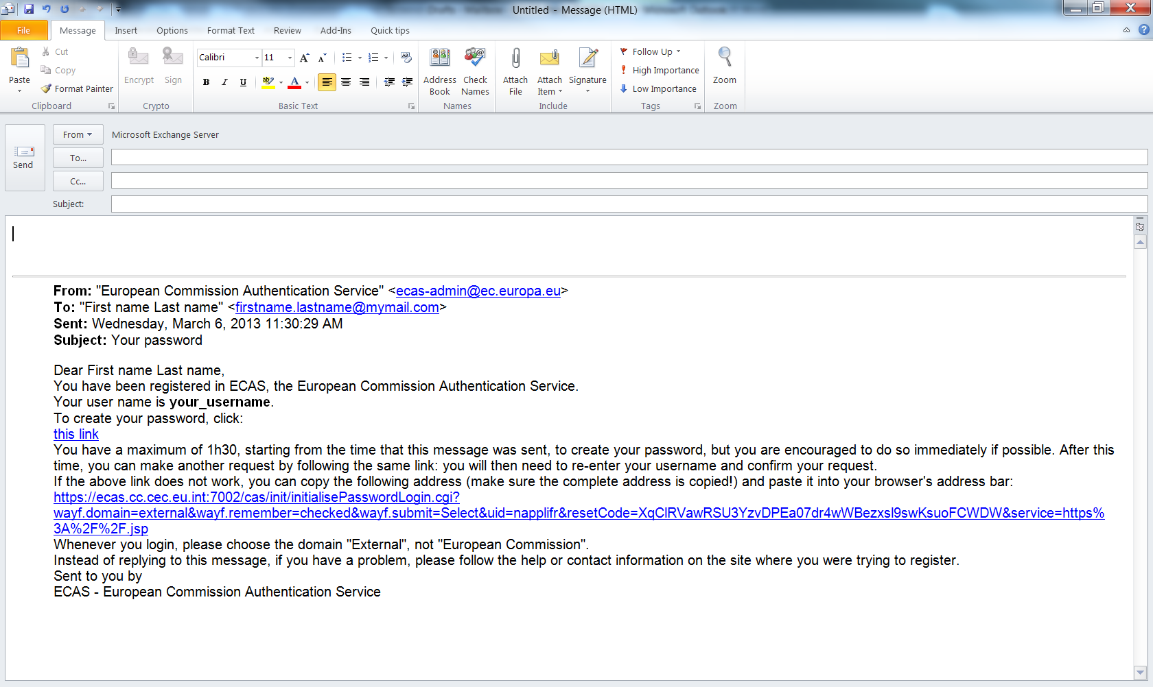
Click on 'this link'

Click on 'this link' to be directed to the ECAS password creation webpage:
Please note: you must complete the password creation within 90 minutes of the email being SENT to you (not within 90 minutes of its arrival)!
Complete the form, respecting the format rules cited on-screen and click 'Submit'.
If you miss the 90 minute deadline, please refer to the instructions contained within the email you received.
When your password has been accepted, the following confirmation screen will appear:
You have now finished creating your ECAS account. Please keep your account details and password in a safe place.
When you log in through ECAS in the future, you can do so either with the username that you chose (or which was generated automatically for you) or with the email address that you used to register your account.

Validating your ECAS account for use with OEET
In anticipation of your assessment activity, you will be sent an email by the EACEA Helpdesk similar to the one below:
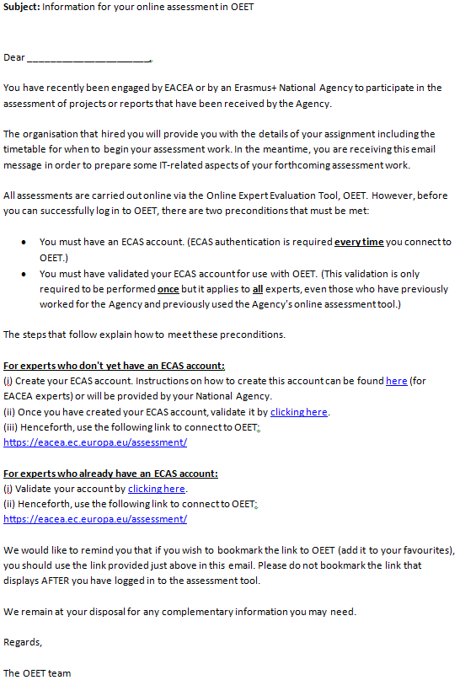

Read the instructions in the email message. When you are ready, click on the relevant link to validate your account. If you are not already logged into your ECAS account, the ECAS login page will appear in your browser:
Log in to your account.
After login, you will be redirected to the EACEA validation webpage:
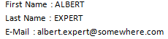
Click on Validate
Click on the Validate button to carry out the validation. After validation, the date and time of the validation will replace the validate button:
Please note the following:
- You will not encounter the ECAS login page if you were already logged into your ECAS account when you clicked on the validation link in the email message.
- If you clicked on the validation link in the email message BEFORE you had created your ECAS account you will be redirected to ECAS to create your account (see section 3 above). Following the creation of your account, you will be redirected to the EACEA validation webpage.

Logging in to the Online Expert Evaluation Tool
Once you have validated your ECAS account for use with OEET you will be able to log into the tool. (These are also the steps to follow when you are returning to OEET for subsequent assessment activity.)

Link to the tool
Click on the following link to connect to the Online Expert Evaluation Tool:
https://eacea.ec.europa.eu/assessment/
You will be directed to the ECAS login page. (NB if you have ALREADY logged in to your ECAS account during the active browser session, you will not need to log in again but will be transferred directly to the Online Expert Evaluation Tool.)
Should you encounter a 'Security Warning' message like the one that follows, always click the 'No' button to open the webpage:
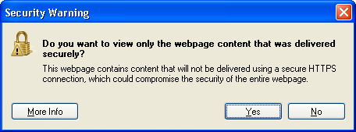
Click
'No'

ECAS Login
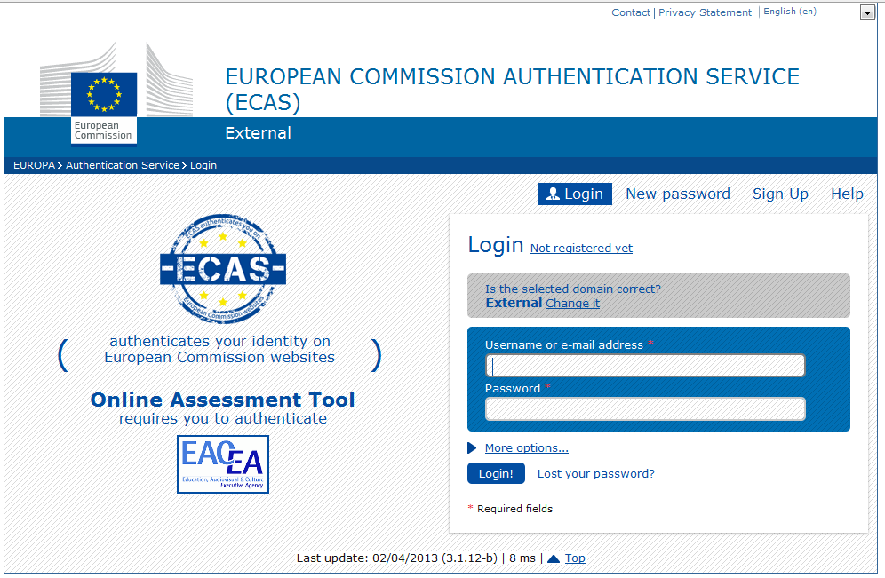
- Enter your ECAS username or your email address and your password
- Click the Login button

Whilst your details are being authenticated, the following screen momentarily appears:

Assessment List

On successful authentication, you are directed to the Online Expert Evaluation Tool to a page listing the programme(s) and action(s) that you have been engaged to work on:
If you see a header with an empty screen, it means you haven't yet been assigned to any programme. In this scenario, please contact your National Agency.
For guidance on recording your assessments please now consult sections 3.2 and 4 of the document, 'OEET Expert User Manual' (or consult whatever alternative user documentation or briefing materials your National Agency have provided you with).

Logging out of OEET
There is no logout button or link. Simply close the browser tab or the whole browser to end the online session. Make sure you perform a save of any assessment work you had started before ending your session.

